**4.1 Sociodemographic factors of the participants**

Majority of the participants (71%) were within the age group 36-45 years, as more than half of them were female (57%) and married (52%). Most of the participants had secondary education (51%), half of them were unemployed (50%) and the majority earns between 100,000-150,000 monthly. Majority of the participants (68.5%) has been diagnosed of diabetes for the duration of 1-5 years, while majority of them (73%) do not have any complications such as retinopathy and neuropathy. See Table 4.1

**Table 4.1. Sociodemographic factors**

| **Characteristic** | **N = 200** |
| --- | --- |
| Age |  |
| >56 years | 1 (0.5%) |
| 15-25 years | 29 (14.5%) |
| 36-45 years | 142 (71%) |
| 46-55 years | 28 (14%) |
| Gender |  |
| Female | 86 (43%) |
| Male | 114 (57%) |
| Marital Status |  |
| Divorced | 1 (0.5%) |
| Married | 104 (52%) |
| Single | 94 (47%) |
| Widowed | 1 (0.5%) |
| Level of Education |  |
| No formal education | 2 (1.0%) |
| Primary | 2 (1.0%) |
| Secondary | 101 (51%) |
| Tertiary | 95 (48%) |
| Occupation |  |
| Government employee | 25 (13%) |
| Self-employed | 76 (38%) |
| Unemployed | 99 (50%) |
| Monthly Income |  |
| #100000 - #150000 | 101 (51%) |
| #20000 - #50000 | 2 (1.0%) |
| #51000 - #100000 | 39 (20%) |
| > # 200000 | 58 (29%) |
| Duration of Diabetes Diagnosis |  |
| < 1 year | 17 (8.5%) |
| >10 years | 16 (8.0%) |
| 1-5 years | 137 (68.5%) |
| 6-10 years | 30 (15%) |
| Presence of Complications |  |
| Not sure | 36 (18%) |
| No | 146 (73%) |
| Yes | 18 (9.0%) |

**4.2 The Quality of Life among the participants**

The quality of life of the participants was assessed by the WHOQOL-BREF instrument, the instrument has four domains; physical health, psychological health, social relationships and environment. The mean of each domain is calculated to give a set of raw score, the raw scores are transformed to a 0-100 scale, to make the domains comparable. See the formula below

Scoring formula

Transformed score = [(raw score – lowest possible raw score) / (highest possible raw score – lowest possible raw score)] * 100

As regard the participants’ overall health, most of them (79.5%) claimed their overall health is very poor.

The mean and SD score of the domains are presented in table 4.2 as follows: physical health (29.650 ± 9.622), psychological health (41.550 ± 12.575), social relationships (38.708 ± 7.467), environment (36.250 ± 7.242). The overall mean and SD of the quality of life in this study was 36.539 ± 4.487, see table 4.2 The overall quality of life was classified into poor, fair and good based on the classification scheme on table 4.2.2, it was observed that majority of the participants (99%) had poor QOL while the remaining had fair QOL.

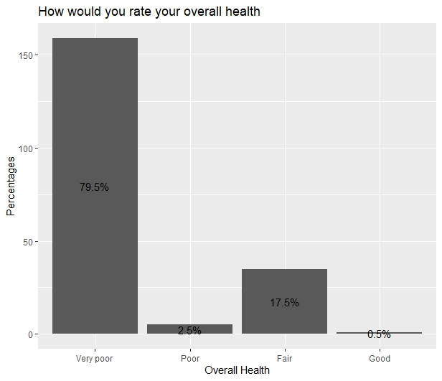

Figure 4.1 Overall health of the Type 2 diabetic patients attending the Medical Outpatient Department (MOPD) at Ahmadu Bello University Teaching Hospital (ABUTH), Zaria, Nigeria.

**Table 4.2 Descriptive summary of the 4 domain of the WHOBREF in the study**

| **variable** | **n** | **min** | **max** | **median** | **IQR** | **mean** | **S.D** |
| --- | --- | --- | --- | --- | --- | --- | --- |
| Physical health | 200 | 10 | 65.000 | 30.000 | 10.000 | 29.650 | 9.622 |
| Psychological health | 200 | 10 | 65.000 | 35.000 | 15.000 | 41.550 | 12.575 |
| Social relationships | 200 | 25 | 58.333 | 41.667 | 8.333 | 38.708 | 7.467 |
| Environment | 200 | 5 | 65.000 | 35.000 | 10.000 | 36.250 | 7.242 |
| Total | 200 | 23.333 | 62.080 | 36.667 | 5.940 | 36.539 | 4.487 |

The classification scheme for the WHO BREF Quality of Life

|  |  |  |  |
| --- | --- | --- | --- |
| Category | Range | Frequency | % |
| Normal | 76-100 | 0 | 0 |
| Mild | 51-75 | 2 | 1.0 |
| Moderately impaired | 26-50 | 195 | 97.5 |
| Severely impaired | 0-25 | 3 | 1.5 |

**Table 4.2.2: The classification scheme for the WHO BREF Quality of Life**

|  |  |  |  |
| --- | --- | --- | --- |
| **Category** | **Range** | **Frequency** | **%** |
| **Physical Domain** |  |  |  |
| Good | 65-100 | 1 | 0.5 |
| Fair | 45-64 | 8 | 4.0 |
| Poor | <45 | 191 | 95.5 |
| **Psychological health Domain** |  |  |  |
| Good | 65-100 | 30 | 15.0 |
| Fair | 45-64 | 54 | 27.0 |
| Poor | <45 | 116 | 58.0 |
| **Social relationship Domain** |  |  |  |
| Good | 65-100 | 0 | 0 |
| Fair | 45-64 | 18 | 9.0 |
| Poor | <45 | 182 | 91.0 |
| **Environment Domain** |  |  |  |
| Good | 65-100 | 1 | 0.5 |
| Fair | 45-64 | 33 | 16.5 |
| Poor | <45 | 166 | 83.0 |
| **Overall QOL** |  |  |  |
| Good | 65-100 | 0 | 0 |
| Fair | 45-64 | 2 | 1.0 |
| Poor | <45 | 198 | 99.0 |

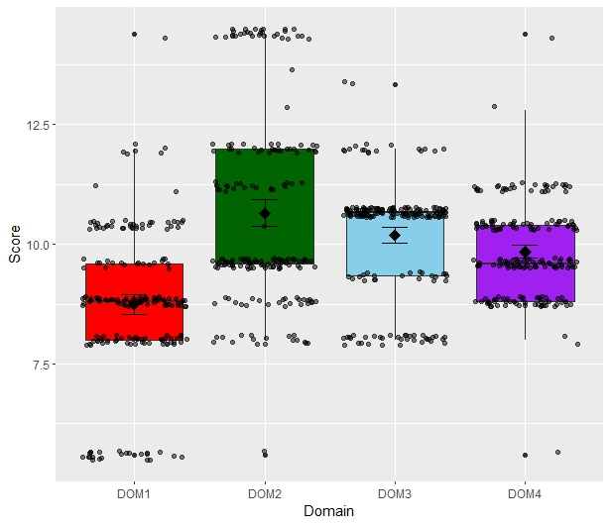

Fig 4.2 Boxplot with Jitter points of the participants in this study, DOM1 = physical, DOM2 = psychological health, DOM3 = Social relationships, DOM4 = Environment.

**4.3 The effect of selected socio-demographical factors on the quality of life of the participants**

The effect of the age, gender, level of education and monthly income on the quality of life was examined using the analysis of variance test (ANOVA) while taking significance at p-value < 0.05. It was observed that, age group had significant effect on the physical domain (0.023) and the environment domain (p-value < 0.001), gender had significant effect on the environment domain (p-value = 0.015), level of education had significant effect on the physical domain (p-value = 0.002) and the environmental domain (p-value <0.001), monthly income had significant effect on the physical (p-value = 0.001), psychological (p-value < 0.001) and the environment domain (p-value < 0.001).

4.3.1 Hypothesis

H0: There is no significant association between socio-demographic factors (age, gender, educational level, income) and the quality of life among Type 2 diabetic patients attending the MOPD at ABUTH, Zaria.

H1: There is a significant association between socio-demographic factors (age, gender, educational level, income) and the quality of life among Type 2 diabetic patients attending the MOPD at ABUTH, Zaria.

We fail to accept the null hypothesis (H0) because there were statistically significant difference/association between socio-demographic factors and the quality of life, hence we accept the alternative hypothesis H1: µ1 ≠ µ2

Table 4.3. The effect of selected socio-demographical factors on the quality of life of the participants

| Variables | Physical Health | | Pyschological | | Social Relationship | | Environment | |
| --- | --- | --- | --- | --- | --- | --- | --- | --- |
|  | Mean | SD | Mean | SD | Mean | SD | Mean | SD |
| Age Group |  |  |  |  |  |  |  |  |
| 15-25 years | 34.65 | 5.33 | 39.31 | 9.23 | 37.06 | 4.76 | 36.20 | 5.77 |
| 36-45 years | 28.94 | 9.87 | 41.44 | 13.88 | 38.73 | 8.43 | 35.14 | 7.50 |
| 46-55 years | 28.03 | 10.57 | 44.10 | 7.46 | 40.17 | 3.25 | 41.60 | 4.31 |
| >56 years | 30.00 | - | 50.00 | - | 41.66 | - | 45.00 | - |
| P-value | 0.023* |  | 0.471 |  | 0.453 |  | <0.001* |  |
| Gender |  |  |  |  |  |  |  |  |
| Female | 30.69 | 9.55 | 42.90 | 12.04 | 38.95 | 8.80 | 34.82 | 9.08 |
| Male | 28.85 | 9.64 | 40.52 | 12.92 | 38.52 | 6.31 | 37.32 | 5.24 |
| P-value | 0.182 |  | 0.186 |  | 0.688 |  | 0.015* |  |
| Level of Education |  |  |  |  |  |  |  |  |
| No formal education | 25.00 | 0.00 | 45.00 | 0.00 | 33.33 | 0.00 | 5.00 | 0.00 |
| Primary | 37.50 | 10.60 | 50.00 | 0.00 | 41.66 | 0.00 | 40.00 | 7.07 |
| Secondary | 31.98 | 9.11 | 41.03 | 11.32 | 38.36 | 8.08 | 36.53 | 5.41 |
| Tertiary | 27.10 | 9.60 | 41.84 | 14.01 | 39.12 | 6.88 | 36.73 | 6.51 |
| P-value | 0.002* |  | 0.739 |  | 0.606 |  | <0.001* |  |
| Monthly Income |  |  |  |  |  |  |  |  |
| #100000 - #150000 | 26.18 | 8.37 | 39.80 | 13.47 | 39.19 | 6.40 | 36.13 | 5.60 |
| #20000 - #50000 | 25.00 | 0.00 | 45.00 | 0.00 | 33.33 | 0.00 | 5.00 | 0.00 |
| #51000 - #100000 | 35.12 | 12.11 | 35.25 | 5.95 | 41.66 | 8.76 | 36.41 | 5.61 |
| > # 200000 | 32.15 | 7.32 | 48.70 | 11.18 | 36.06 | 7.54 | 37.75 | 6.69 |
| P-value | <0.001* |  | <0.001* |  | 0.002* |  | <0.001* |  |

*-significant at p-value <0.05